Two Arms of One Curve: Cooling and Heating Degree Days and Monthly Residential Electricity Sales in North Carolina, 1990–2026

Shubham Jalan
Independent Researcher
October 2026

Abstract
Studies of weather and electricity demand in the Southeast tend to focus on summer cooling, but many North Carolina homes also heat with electricity. I used 436 months of public data (January 1990 to April 2026) from NOAA’s nClimDiv dataset and Form EIA-861M to estimate how statewide residential electricity sales respond to both cooling and heating degree days. Because sales nearly doubled over the period, I modeled the log of sales, so that the weather effect grows with the size of the system. A model with cooling degree days alone explained R² = .13 of the variation in log sales. Adding heating degree days raised this to .45, and adding a linear trend raised it to .85. In that model, 100 more cooling degree days in a month went with 18.7% higher sales, 95% CI [18.0, 19.5], and 100 more heating degree days with 8.7% higher sales, 95% CI [8.3, 9.1]. Heating and cooling each accounted for a similar share of annual sales. The heating-to-cooling ratio ranged from 0.87 to 1.24 across specifications, so neither can be called the larger one. Between 2008 and 2026, each degree day was tied to less electricity per customer, by 15% to 27% for cooling. Most of that drop tracks a general decline in use per customer: in proportional terms the cooling response fell by only 6% to 12%, and that change was not robust.
Keywords: cooling degree days, heating degree days, residential electricity demand, temperature response, North Carolina

Two Arms of One Curve: Cooling and Heating Degree Days and Monthly Residential Electricity Sales in North Carolina, 1990–2026
Residential electricity demand in the southeastern United States is growing, and air conditioning is a large part of it. Nationally, air conditioning accounts for about 19% of residential electricity use (U.S. Energy Information Administration [EIA], 2024), and 93% of households in the South Census region have it (EIA, 2022). Duke Energy expects customer energy needs in the Carolinas to grow over the next 15 years at roughly eight times the rate of the previous 15 (Duke Energy, 2025).
The standard way to link temperature and demand is the degree day. A day’s cooling degree day (CDD) value is the number of degrees its mean temperature sits above 65 °F, and its heating degree day (HDD) value is the number of degrees below 65 °F. Monthly totals add up the daily values (EIA, 2023b). Demand rises when it gets either hotter or colder than this balance point, so a plot of demand against temperature has two arms: cooling on the right and heating on the left (Hu et al., 2024). Many studies in the Southeast look only at the cooling arm. That makes sense in Florida, but less so in a state where many homes heat with electricity.
North Carolina is one of those states. In the 2020 Residential Energy Consumption Survey, 38% of its housing units listed a central heat pump as their main heating equipment. That is behind South Carolina (41%) and Alabama (39%) but among the higher shares in the country (EIA, 2023a). The state’s cooling degree days have also been rising and its heating degree days falling (Kunkel et al., 2020), so the balance between the two arms may be shifting.
I asked three questions. How does the estimated weather response change when heating degree days and a trend are added to a cooling-only model? How large are the heating and cooling parts of annual sales compared with each other? And has the response per customer changed over the years for which customer counts are available? The data are statewide monthly totals, so the results describe associations in monthly energy (MWh). They are not causal estimates and do not cover peak power.
Background
Degree-day regression has a long history in building energy analysis. The PRISM method fit a household’s metered use to degree days and estimated its balance point from the data (Fels, 1986). At the state level, Sailor and Muñoz (1997) related monthly electricity and natural gas use to climate variables, including degree days, for eight U.S. states and found that the sensitivity differed considerably from state to state. Auffhammer and Mansur (2014) review the later literature, which ranges from simple degree-day models like these to studies of household billing data and long-run climate projections.
Regional studies in the South show how strong the link is. Cawthorne et al. (2021) modeled seasonal demand in Tennessee and Texas and, after removing population growth, found that temperature explained 44% to 67% of the seasonal variation (Figure 1). Fache and Bhat (2024) found temperature to be among the strongest predictors of residential demand in Florida in a model that also included population, employment, GDP, electricity price, and daylight hours. Auffhammer et al. (2017) showed that warming is likely to raise peak demand more than total energy use, which is a reminder that monthly totals like the ones here do not say much about peaks.
Figure 1
Residuals of Electricity Demand Versus Population-Weighted Average Temperature for Tennessee (A: Winter, B: Summer) and Texas (C: Winter, D: Summer)
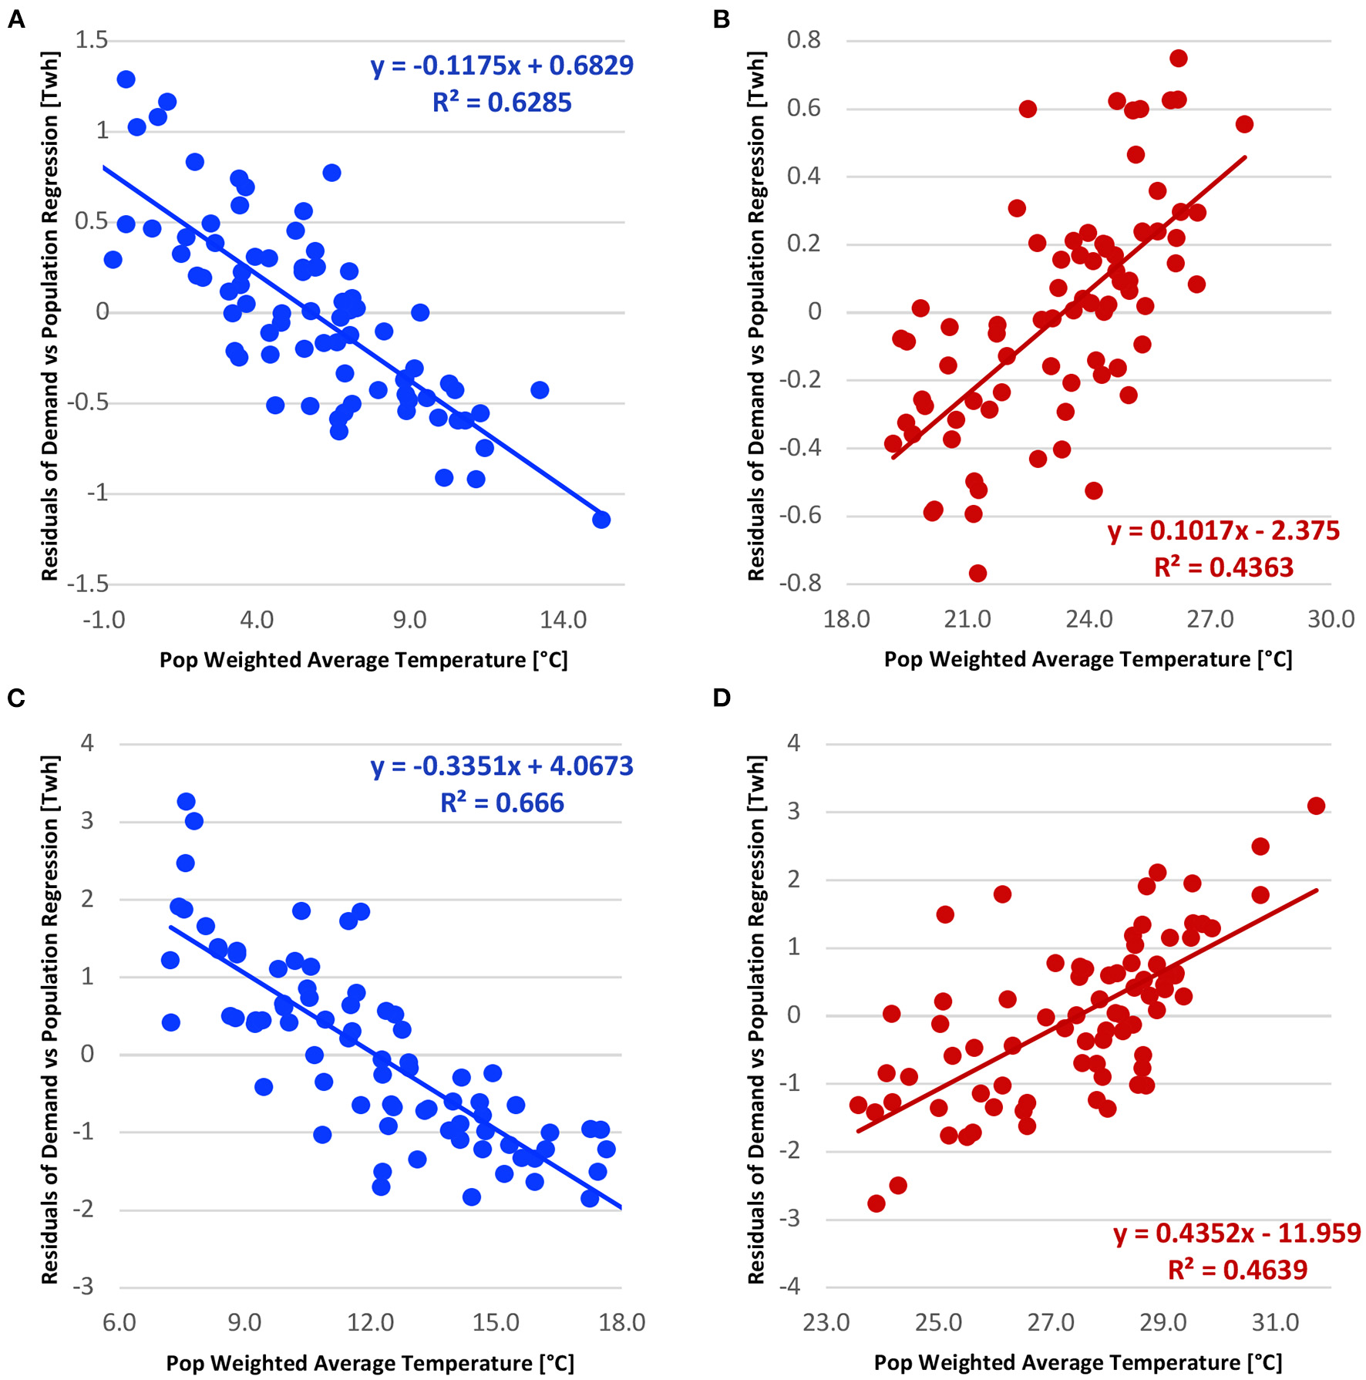
Note. From Cawthorne et al. (2021), Frontiers in Sustainable Cities, licensed under CC BY 4.0. Winter panels slope down and summer panels slope up.
Hu et al. (2024) studied this two-armed temperature response function for 36 European countries and projected how it might change with more air conditioning, better insulation, and electric heating (Figure 2). Their work is about future scenarios in Europe, but it raises a question that can be checked with past data for North Carolina: has the curve here stayed in place? I found few studies that estimate both arms for North Carolina at the statewide monthly level or test whether they have shifted, and this study does both with public federal data.
Figure 2
Illustrative Two-Armed Temperature Response Function
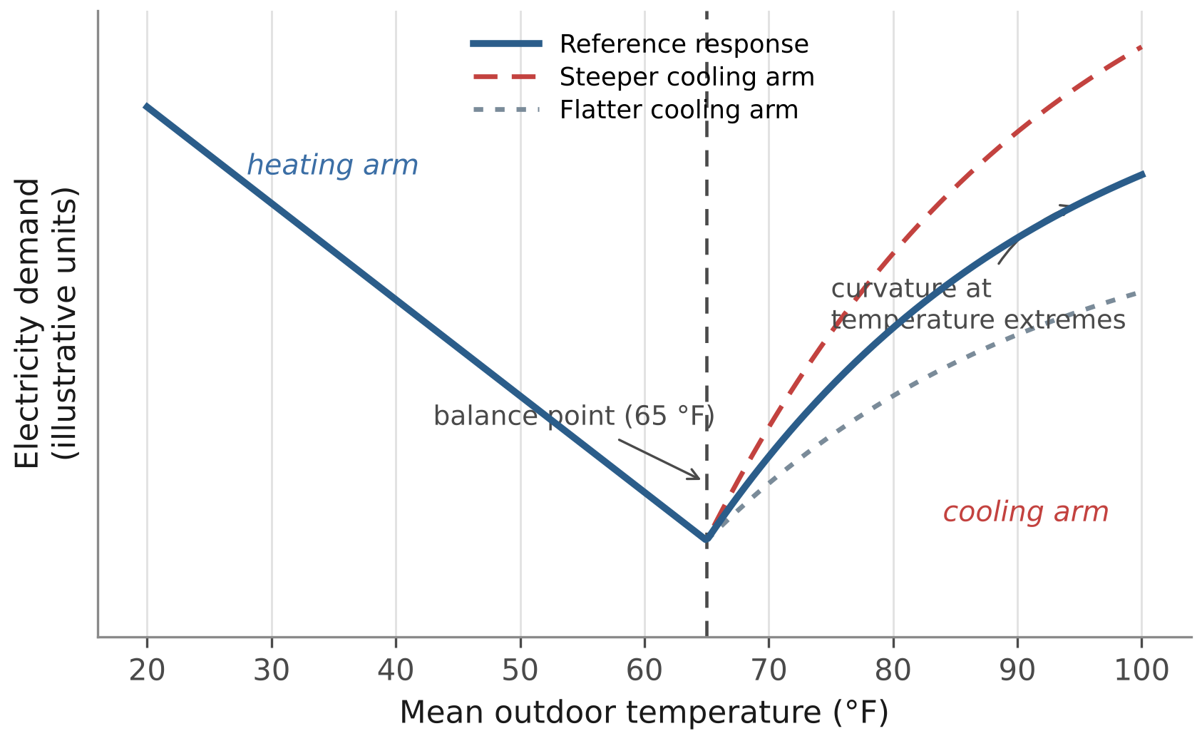
Note. Drawn by the author from the balance-point idea (EIA, 2023b) and Hu et al. (2024). The curves are not fitted to data. The steeper and flatter cooling arms show what a change in the response would look like.
Method
Data
Statewide monthly cooling degree days, heating degree days, and mean temperature for North Carolina came from NOAA’s nClimDiv dataset (National Oceanic and Atmospheric Administration, 2026; state code 031). These values are averaged by area, not population. Monthly residential electricity sales (MWh), customer counts, and average revenue per kilowatt-hour came from Form EIA-861M (EIA, 2026). I joined the two sources on year and month. All 436 months from January 1990 to April 2026 matched, with no gaps, duplicates, or negative degree-day values. Annual figures use the 36 complete calendar years (1990–2025).
A Break in Customer Counts
Customer counts start in January 2007. Six months changed by more than 2% from the month before (Table 1). January 2008 jumped by +38.1% and never came back down. That is far too large to be real growth, and a change in how customers were counted is the most likely cause, although I did not find EIA documentation confirming it. Either way, customers rose +40.5% from January 2007 to January 2008 while sales rose +12.7%, so sales per customer drops suddenly at that point (Figure 3). I therefore used the 220 months from January 2008 onward for all per-customer models. The five months in 2021–22 move up and down rather than shifting the level (the net change from May 2021 to April 2022 is +2.88%, about normal yearly growth), so I kept them and checked what happens without them.
Table 1
Months With a Change in Reported Residential Customers Above 2%
Month | Customers | Change from prior month
2008-01 | 4,120,654 | +38.10%
2021-06 | 4,798,220 | +2.01%
2021-11 | 4,712,982 | -2.25%
2021-12 | 4,838,442 | +2.66%
2022-01 | 4,703,413 | -2.79%
2022-02 | 4,854,867 | +3.22%

Figure 3
Residential Customer Counts in EIA-861M, January 2007 to April 2026
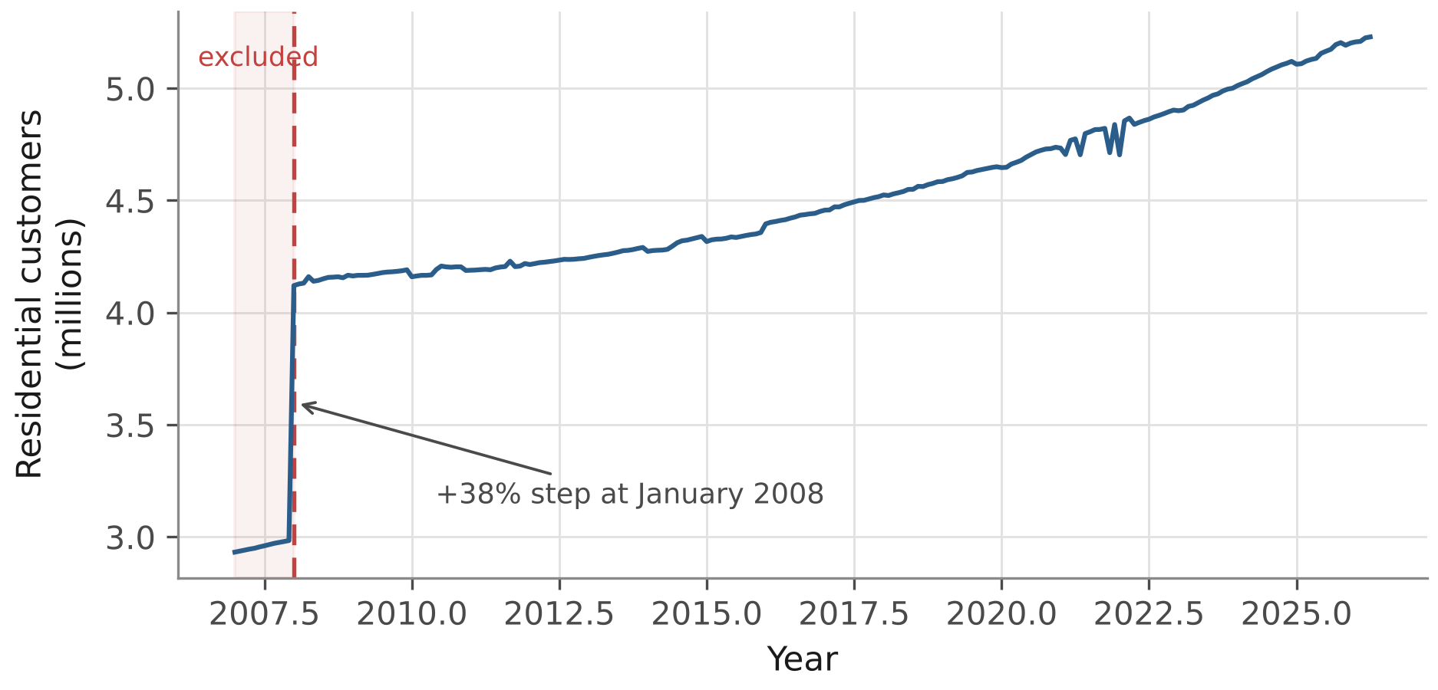
Note. The shaded months before January 2008 are left out of the per-customer models.
Models
Table 2 lists the models. Models 1 to 4 build up from a cooling-only model so that the effect of each addition can be seen. Models 5 to 8 use sales per customer for 2008–2026 and let both degree-day slopes change linearly over time.
Residential sales grew from 33.1 million MWh in 1990 to 64.6 million MWh in 2025. With that much growth, a model in MWh that holds the degree-day slopes fixed is hard to defend: a cold month in 2025 adds more MWh than the same cold month in 1990 because there are more homes. I tested this directly by adding CDD × year and HDD × year terms to Model 3. In MWh, both interactions were large (z = 10.0 and 11.2), and the fitted slopes about doubled between 1990 and 2025 (+97% for cooling, +102% for heating). With log sales as the outcome, the same interactions were small and not significant (p = .091 and p = .110). In other words, the weather effect has stayed roughly constant as a percentage of sales, so Models 1 to 4 use log sales. Coefficients are reported as the percentage change in sales for 100 more degree days in a month.
Table 2
Model Definitions
Model | Outcome | Predictors | Months
1 | Log sales | CDD | 436
2 | Log sales | CDD, HDD | 436
3 | Log sales | CDD, HDD, linear year | 436
4 | Log sales | Model 3 plus 11 calendar-month indicators | 436
5 | Sales per customer | CDD, HDD, year, CDD × year, HDD × year | 220
6 | Sales per customer | Model 5 plus 11 calendar-month indicators | 220
7 | Log sales per customer | Same predictors as Model 5 | 220
8 | Log sales per customer | Same predictors as Model 6 | 220
Note. CDD and HDD are monthly totals with a 65 °F base. Year is centred on the mean of each sample.
Models 3 and 4 use different variation, and I report both. Model 3 uses all month-to-month variation, including the annual cycle, so other things that move with the seasons, such as daylight and holidays, can end up in the degree-day coefficients. Model 4 adds a separate intercept for each calendar month, so its degree-day effects come only from comparing the same month across years, such as a hot July with a mild one. Neither is clearly right, and the gap between them shows how much the answer depends on how seasonality is handled.
For the per-customer question, Models 5 and 6 measure the change in kilowatt-hours per customer per degree day. Models 7 and 8 measure the change in proportional terms. The two can differ if use per customer is falling overall: the response in kWh can fall even if the weather share of each customer’s use stays the same.
Inference
Monthly energy data are autocorrelated, and regressing one trending series on another can make a relationship look stronger than it is (Granger & Newbold, 1974). All intervals and p values therefore use Newey–West standard errors (Newey & West, 1987) with a Bartlett kernel and a 12-month maximum lag, one full seasonal cycle, compared with the standard normal distribution. Because the lag was my choice, I also report results for lags of 3 to 24 months where a conclusion could depend on it.
Heating and Cooling Components
With log sales, the share of a month’s sales that the model assigns to cooling is 1 − exp(−b × CDD), where b is the cooling coefficient, and the same holds for heating. Multiplying by actual sales and averaging the yearly totals gives the average MWh per year tied to each arm. These are model-based estimates, not metered end uses. For the ratio of the heating to the cooling component I used the delta method with the full Newey–West covariance of the two coefficients. As a check, I ran a moving-block bootstrap with blocks of 12 months and 4,000 resamples. Because the blocks are put back in random order, the bootstrap keeps short-run dependence but not the long-run trend.
The ratio was also re-estimated with a quadratic trend, with sales and degree days divided by the number of days in each month, without the last three months (which EIA reports as preliminary), with the original MWh specification, and with temperature thresholds estimated from the data instead of the fixed 65 °F base. nClimDiv only publishes degree days at 65 °F, so for the last check I replaced CDD and HDD with the number of degrees the monthly mean temperature sat above a cooling threshold or below a heating threshold, times the days in the month, and chose both thresholds by grid search.
Results
Descriptive Statistics
Over the 36 complete years, North Carolina averaged 1,476 cooling and 3,303 heating degree days per year, a ratio of 2.24 to 1. Monthly sales averaged 4,304,017 MWh (SD = 1,162,451). Table 3 summarizes the monthly variables. Sales peak twice a year on top of steady growth (Figure 4), and both arms of the curve are visible in the raw data (Figure 5).
Table 3
Descriptive Statistics for Monthly Variables, January 1990–April 2026
Variable | n | M | SD | Min | Max
Residential sales (MWh) | 436 | 4,304,017 | 1,162,451 | 2,119,750 | 7,661,069
Cooling degree days | 436 | 122.1 | 153.7 | 0 | 512
Heating degree days | 436 | 276.9 | 279.8 | 0 | 969
Mean temperature (°F) | 436 | 59.6 | 13.2 | 33.6 | 80.7
Monthly sales by season
Winter (Dec–Feb) | 110 | 4,911,755 | 1,048,329
Spring (Mar–May) | 110 | 3,554,993 | 717,349
Summer (Jun–Aug) | 108 | 5,030,111 | 1,141,898
Fall (Sep–Nov) | 108 | 3,721,825 | 845,677

Figure 4
Monthly Residential Electricity Sales, January 1990 to April 2026
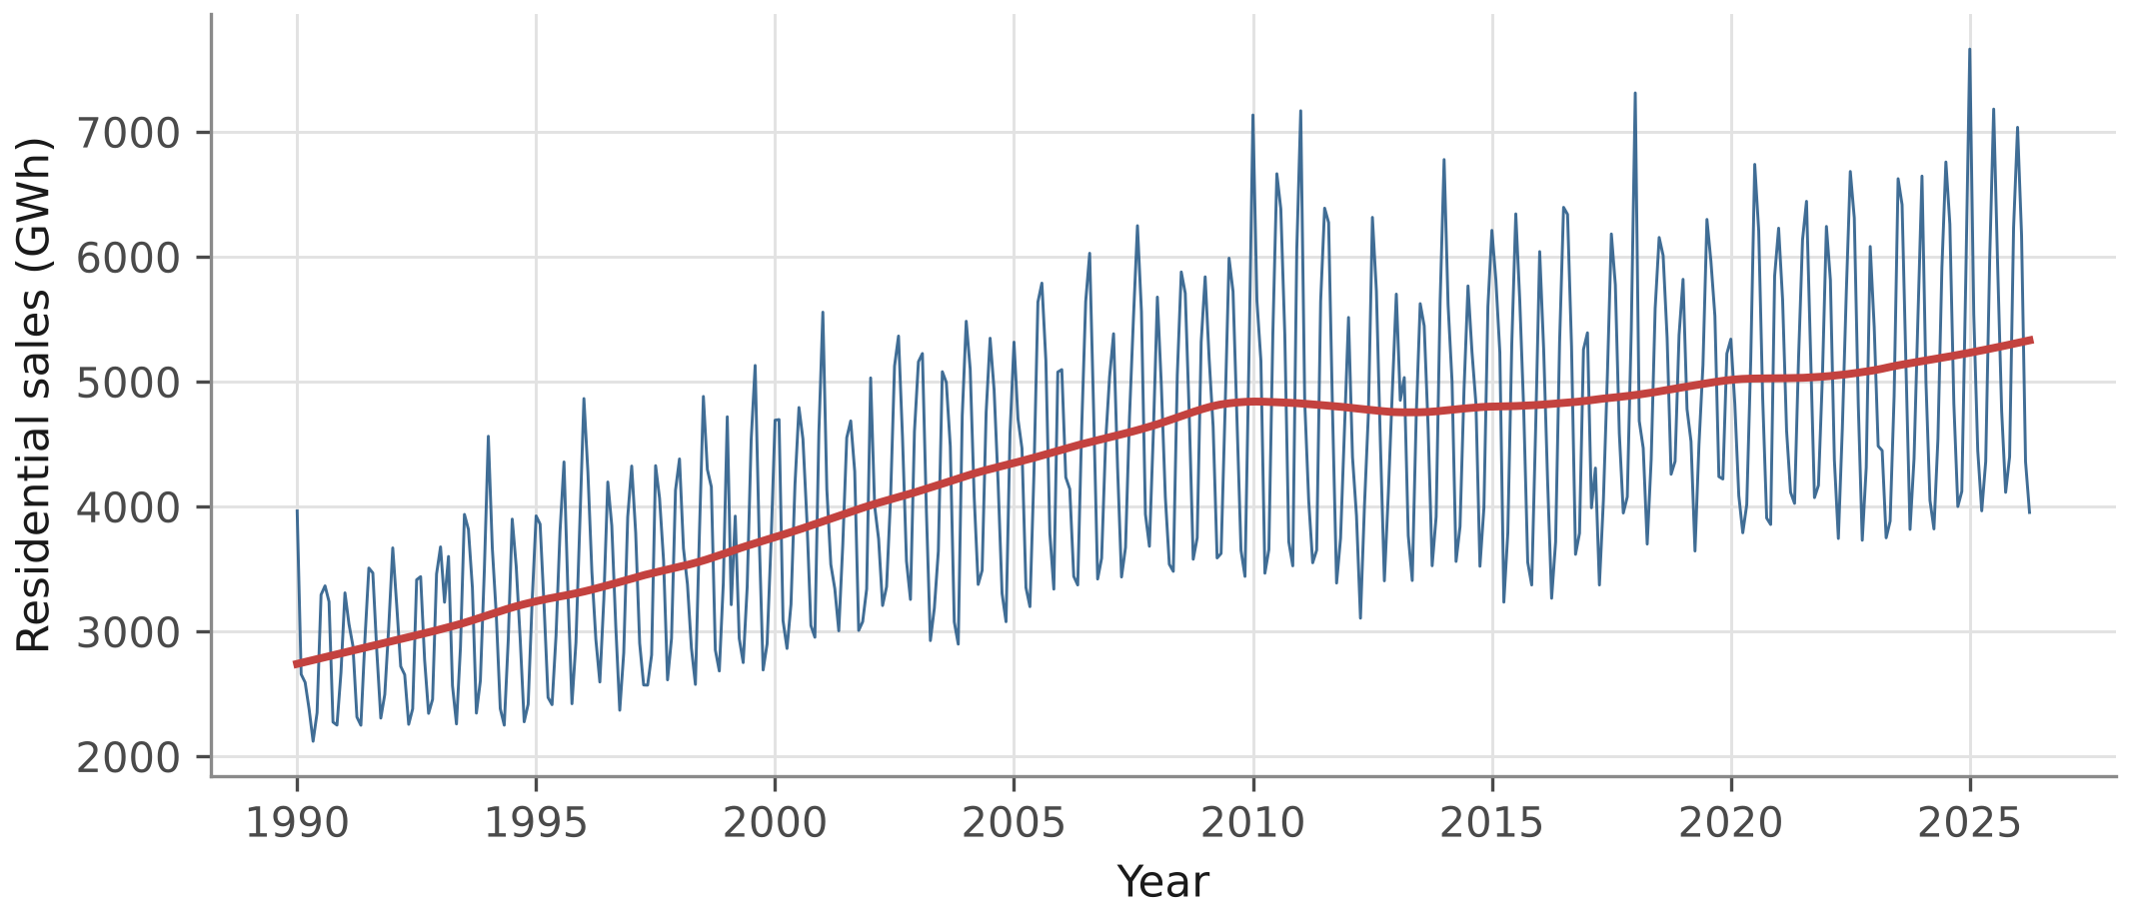
Note. The smooth curve is a LOWESS trend. Sales are in GWh.
Figure 5
Monthly Residential Electricity Sales Against Mean Monthly Temperature
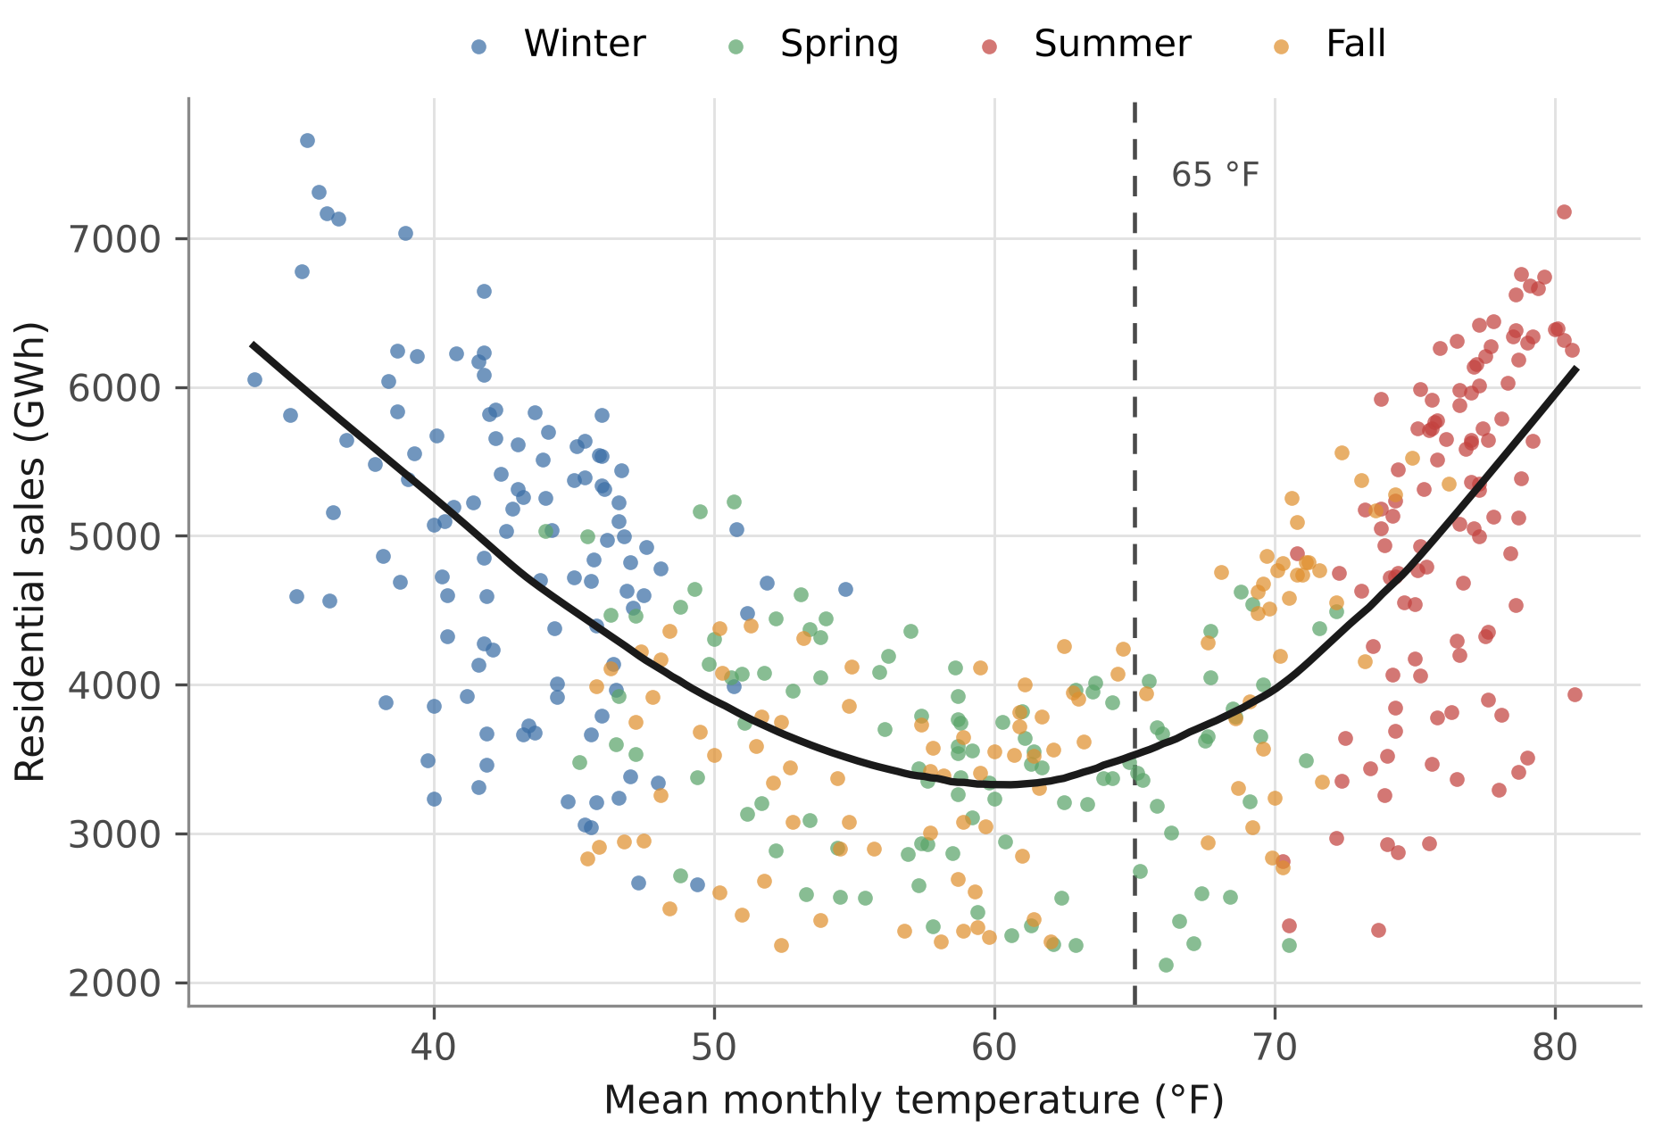
Note. Each point is one month. The curve is a LOWESS smoother and the dashed line marks 65 °F.
Adding Heating Degree Days and a Trend
Cooling degree days alone explained R² = .13 of the variation in log sales. Figure 6 shows why: the 77 months with no cooling degree days cover almost the whole range of sales, because a cooling variable cannot tell a mild November from a cold January. Adding heating degree days raised R² to .45, the trend raised it to .85, and calendar-month effects raised it to .91 (Table 4). The cooling coefficient changed a lot along the way. In Model 1, 100 cooling degree days went with 6.6% higher sales; in Model 3 the figure was 18.7%. Leaving out heating flattens the cooling slope, because the months with no cooling load often have heavy heating loads.
Figure 6
Monthly Cooling Degree Days and Residential Electricity Sales
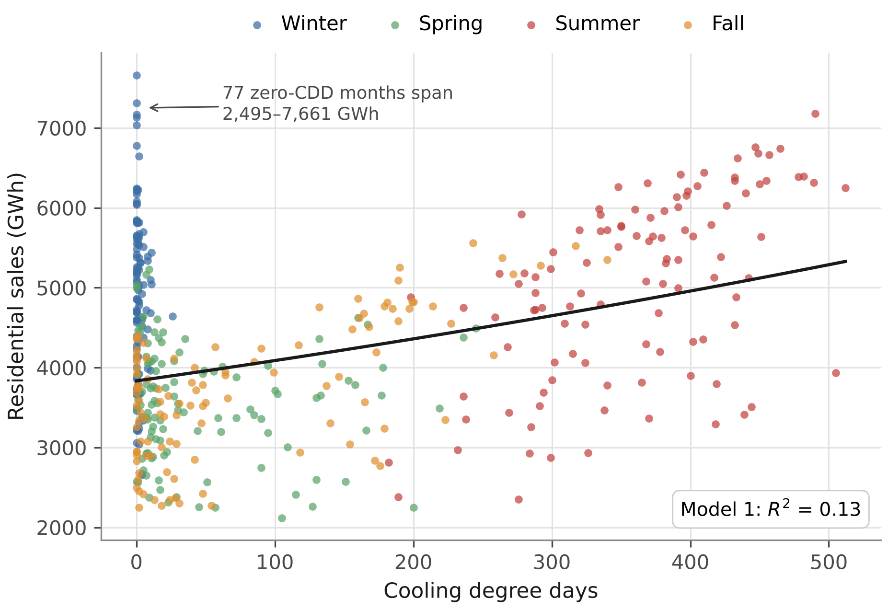
Note. The line is the Model 1 fit.
Table 4
Models of Log Monthly Residential Electricity Sales
Model | CDD | HDD | Year | R² | DW
1 | 6.6 | — | — | .13 | 0.49
 | [5.8, 7.5]
2 | 19.2 | 8.7 | — | .45 | 0.37
 | [18.0, 20.4] | [8.0, 9.3]
3 | 18.7 | 8.7 | 1.69 | .85 | 1.35
 | [18.0, 19.5] | [8.3, 9.1]
4 | 12.1 | 7.4 | 1.71 | .91 | 1.05
 | [8.9, 15.4] | [6.1, 8.6]
Note. N = 436 months. CDD and HDD entries are the percentage change in sales for 100 more degree days in a month, with Newey–West 95% confidence intervals in brackets. Year is the percentage change per year. Model 4 also includes calendar-month indicators. All coefficients have p < .001. DW = Durbin–Watson statistic.
Figure 7 shows the two arms in Model 3 after removing the other predictors. Both are close to linear. In Model 4 the cooling effect is smaller (12.1% per 100 CDD) and the heating effect a little smaller (7.4% per 100 HDD), which fits the idea that part of the Model 3 cooling coefficient picks up other summer effects.
Figure 7
Added-Variable Plots for the Cooling and Heating Terms of Model 3
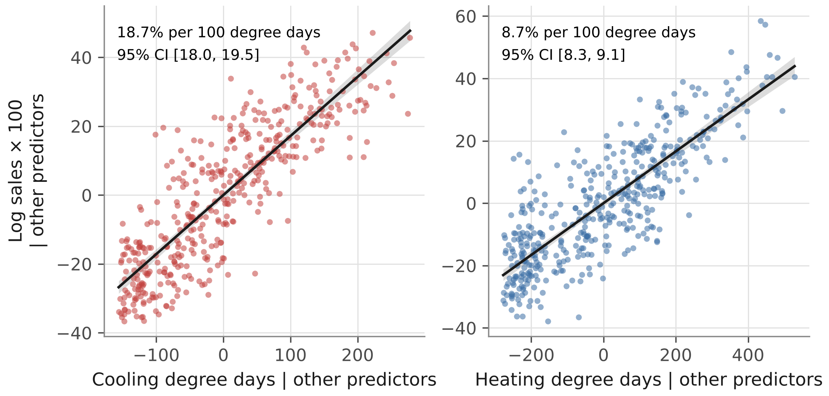
Note. Each panel plots log sales against one degree-day variable after removing the other degree-day variable and the trend. Intervals are Newey–West.
Heating and Cooling Components
In Model 3, cooling accounted for 9.4 million MWh a year (18.3% of sales) and heating for 9.6 million MWh (18.7%), a heating-to-cooling ratio of 1.02. In Model 4 the components were 6.8 and 8.5 million MWh, a ratio of 1.24 (Table 5, Figure 8). Each cooling degree day has a larger effect than each heating degree day, but the state has 2.24 times as many heating degree days, so the two components end up close in size.
Table 5
Annual Heating and Cooling Components Under Models 3 and 4
Quantity | Model 3 | Model 4
Cooling component (million MWh) | 9.4 | 6.8
Heating component (million MWh) | 9.6 | 8.5
Cooling share of annual sales | 18.3% | 13.2%
Heating share of annual sales | 18.7% | 16.5%
Heating ÷ cooling | 1.02 | 1.24
Delta-method 95% CI | [1.00, 1.05] | [0.97, 1.52]
Block bootstrap 95% CI | [1.00, 1.04] | [1.00, 1.62]
Note. Average annual sales over the complete years were 51.5 million MWh. Intervals reflect uncertainty in the coefficients only, not the choice of model.
Figure 8
Heating and Cooling Components of Mean Annual Residential Sales
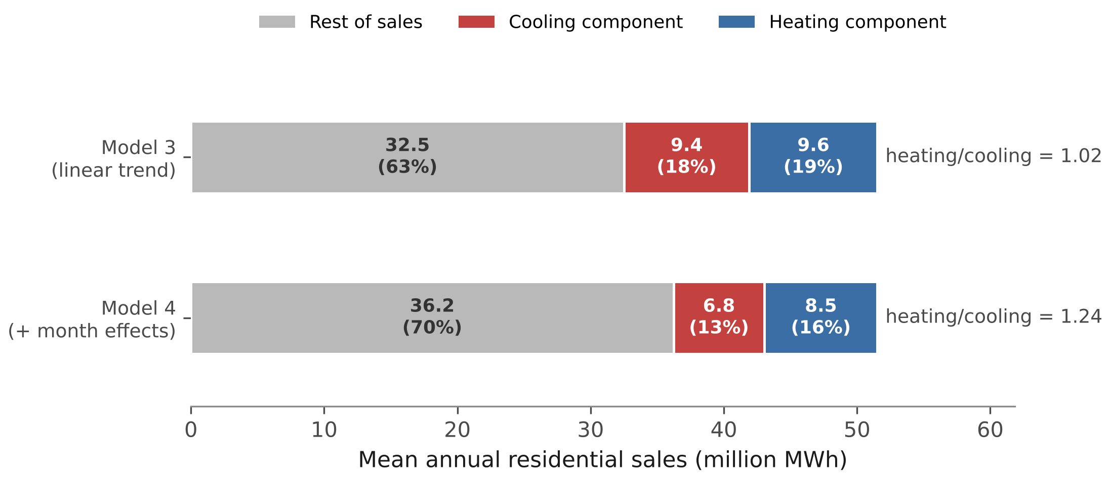
Note. The rest of sales is what the model does not assign to weather. It is not a measured non-weather load.
The ratio was stable under most checks: 1.02 with a quadratic trend, 1.04 using daily averages, and 1.02 without the preliminary months. The thresholds chosen by grid search were 65.0 °F for cooling, the same as the standard base, and 55.5 °F for heating. This model fit slightly better (R² = .86) and gave a ratio of 0.87, with cooling the larger component. For comparison, the original MWh models with fixed slopes gave 1.07 and 1.45. Across these versions the ratio runs from 0.87 to 1.24, so the supported conclusion is that heating and cooling are about the same size. Which one is larger depends on how the model is set up.
Has the Per-Customer Response Changed?
This section uses the 220 months from January 2008 to April 2026. Over that period, annual sales per customer fell from 13.44 MWh in 2008 to 12.52 MWh in 2025, a drop of 6.9%. Table 6 gives the results.
Measured in kWh per customer, the response to cooling degree days fell clearly. The fitted cooling slope was 15.3% lower at the end of the period than at the start in Model 5 (p < .001) and 26.8% lower in Model 6 (p < .001). The heating slope also fell, by 10.6% (p = .094) and 17.1% (p = .010). Figure 9 shows the same pattern in slopes fitted one year at a time.
In proportional terms the picture is weaker. In Model 7 the cooling response fell by 5.6% (p = .170) and in Model 8 by 12.3% (p = .047). The heating response barely moved (p = .962 and p = .346). A test of whether cooling fell faster than heating gave p = .061 in Model 7 and p = .045 in Model 8. So most of the decline in kWh per degree day goes along with the overall decline in use per customer, and only a small part looks specific to cooling.
Table 6
Change in the Per-Customer Degree-Day Response, 2008–2026
Estimate | Model 5 | Model 6 | Model 7 | Model 8
Outcome | kWh | kWh | Log | Log
Calendar-month effects | No | Yes | No | Yes
Change in cooling response | -15.3% | -26.8% | -5.6% | -12.3%
p (CDD × year) | < .001 | < .001 | .170 | .047
Change in heating response | -10.6% | -17.1% | 0.2% | -5.4%
p (HDD × year) | .094 | .010 | .962 | .346
p (cooling fell faster) | — | — | .061 | .045
R² | .88 | .94 | .87 | .95
Note. n = 220 months. Change compares the fitted slope at the first and last month. p values use Newey–West standard errors with a 12-month lag. Whether cooling fell faster than heating is only tested in the log models, where both are on the same percentage scale.
Figure 9
Per-Customer Response Slopes by Year and the Change Implied by Models 5 to 8
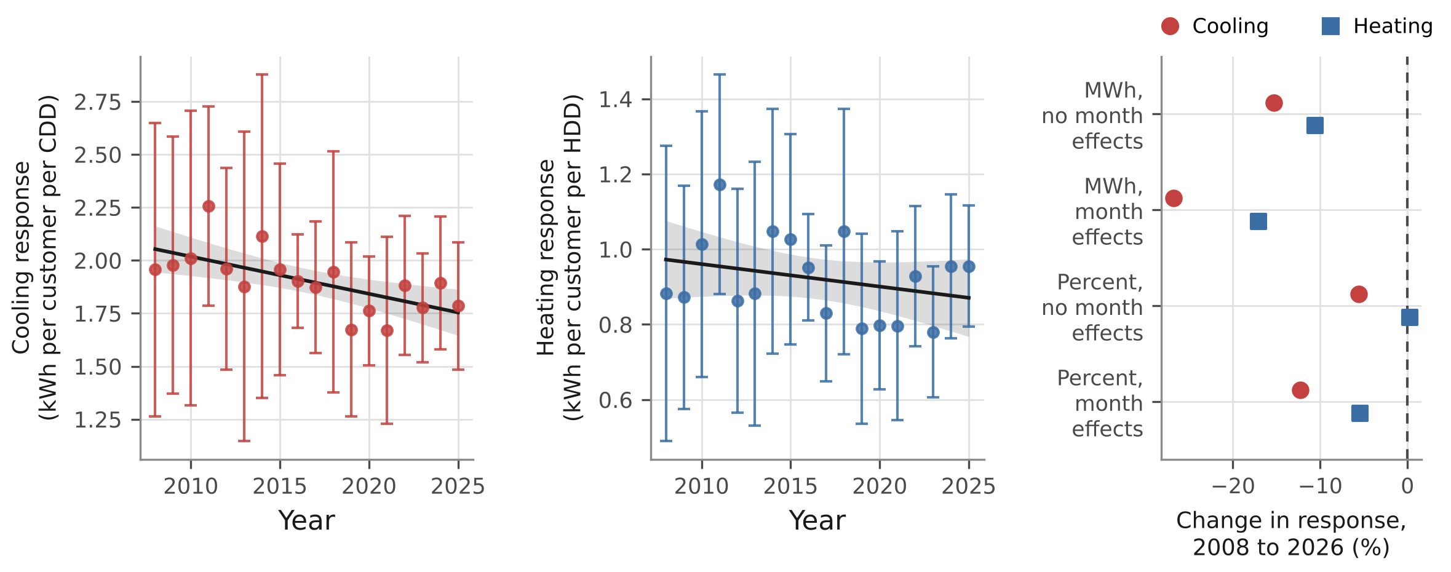
Note. Left and centre: slopes fitted within each year from 12 months of data, with 95% intervals and a straight-line trend. Right: the change in the cooling and heating responses from the start to the end of the period in each model.
The kWh decline in cooling held at every lag from 3 to 24 months (largest p = .010). The proportional decline did not: in Model 8 its p value ranged from .024 to .083 across lags, and in Model 7 it was never below .152. Table 7 shows the same split across time windows. Dropping the 2021–22 months changed little. Including 2007, across the customer-count break, made the kWh decline look larger and the proportional decline disappear.
Table 7
Change in the Cooling Response Under Different Estimation Windows
Window | n | kWh (Models 5 / 6) | Log (Models 7 / 8)
2008-2026 | 220 | -15.3% / -26.8% | -5.6% / -12.3%
2007-2026 | 232 | -21.6% / -31.4% | -2.3% / -6.2%
2009-2026 | 208 | -15.6% / -26.3% | -5.3% / -11.6%
2008-2026 without 2021-22 | 215 | -15.4% / -26.2% | -5.6% / -11.7%
p values
2008-2026 |  | < .001 / < .001 | .170 / .047
2007-2026 |  | .010 / .005 | .721 / .552
2009-2026 |  | < .001 / < .001 | .207 / .078
2008-2026 without 2021-22 |  | < .001 / < .001 | .175 / .046
Note. The first row is the main analysis. The fourth drops the five 2021–22 months in Table 1.
Other Checks
Removing a linear trend from both series raised the correlation between cooling degree days and log sales from .36 to .44. It was .58 on first differences and .41 on twelve-month differences, so the relationship is not just two series trending together. Residual plots are in Appendix Figures A1 to A3. Model 3 still has residual autocorrelation of .67 at a 12-month lag, and Model 4 has .54, which is why I use Newey–West standard errors throughout. The Model 3 and 4 degree-day coefficients stayed significant at every lag from 3 to 24 months (smallest z = 7.7).
Discussion
A cooling-only model fits North Carolina’s residential sales poorly because it leaves out heating, not because the cooling relationship is weak. Adding heating degree days raised R² from .13 to .45 and raised the cooling coefficient from 6.6% to 19.2% per 100 CDD. In a state where many homes heat with electricity, the heating arm needs to be in the model.
The choice between MWh and log sales also matters. Over 36 years of growth, a fixed MWh slope mixes the response of a small 1990 system with that of a much larger 2025 one. The log model fixes this, and its slopes were stable over time. It also moved the heating-to-cooling ratio from 1.07–1.45 in MWh to 1.02–1.24 in logs.
Heating and cooling come out at about the same size, each around 13% to 19% of annual sales. A cooling degree day is tied to 1.6 to 2.1 times as much electricity as a heating degree day. Efficiency alone does not explain this, since heat pumps and air conditioners use the same cycle. A more likely reason is that nearly all homes in the South cool with electricity (EIA, 2022) but only some heat with it. The survey reports main heating equipment, not fuel: 38% of North Carolina housing units use a central heat pump and 50% a furnace, without a split by fuel (EIA, 2023a). Homes with gas furnaces still use some electricity for blowers. Humidity, which degree days do not capture, and heat pumps switching to resistance backup in cold weather could also play a part. This study cannot separate these.
The per-customer results contain two different findings. Each cooling degree day is now tied to fewer kWh per customer than in 2008, and the same is probably true for heating, though that was significant in only one of the two models. But use per customer fell over the same years, and in proportional terms the weather response changed much less and not consistently. Possible causes of the overall decline include more efficient equipment (federal minimum standards for central air conditioners rose in 2006, 2015, and 2023; Air-Conditioning, Heating, and Refrigeration Institute, 2023), better-insulated homes, and changes in who the customers are. I did not test these. A falling per-customer response also does not mean total weather-driven use is falling, since customers grew from 4,120,654 in January 2008 to 5,229,187 in April 2026.
Conclusion
Cooling degree days are tied to higher residential electricity sales in North Carolina, but a model built on them alone leaves out the heating arm, which is about as large. With heating degree days, a trend, and log sales, the two arms account for similar shares of annual sales, and which is larger depends on the model. Per customer, each degree day now goes with less electricity than in 2008, mostly in step with lower use per customer overall.
Limitations
This is an observational study of statewide totals. It cannot see differences between counties and does not identify causal effects. nClimDiv degree days are weighted by area, not population, so they do not exactly match where electricity is used. The threshold check uses monthly mean temperatures, which hide hot and cold days within a month, so its thresholds are not the same thing as a daily balance point. The linear trend stands in for population, income, prices, and efficiency all at once. The per-customer analysis depends on dropping the months before the 2008 customer-count break, whose cause is not documented. EIA revises recent months, though dropping the last three did not change the results. Finally, all R² values are in-sample, and the paper makes no forecasting claims.
Future Research
County or utility data would allow population-weighted degree days, and daily data would allow the balance point to be estimated properly. Hourly load data would make it possible to study peak demand. Repeating the analysis across southern states with different shares of electric heating would help explain why a cooling degree day carries more electricity than a heating degree day.
Data and Code Availability
All data are public. The code, data, and results are at https://github.com/Shubham6883/nc-degree-day-electricity. The analysis was run in Python 3.13.16 with NumPy 2.5.3 and pandas 3.0.5.
Use of AI Tools
I used Claude (Anthropic) to edit and refine the analysis code and help verify the results. I am responsible for the content of the paper.

References
Air-Conditioning, Heating, and Refrigeration Institute. (2023). 2023 energy efficiency standards. https://www.ahrinet.org/2023-energy-efficiency-standards
Auffhammer, M., Baylis, P., & Hausman, C. H. (2017). Climate change is projected to have severe impacts on the frequency and intensity of peak electricity demand across the United States. Proceedings of the National Academy of Sciences, 114(8), 1886–1891. https://doi.org/10.1073/pnas.1613193114
Auffhammer, M., & Mansur, E. T. (2014). Measuring climatic impacts on energy consumption: A review of the empirical literature. Energy Economics, 46, 522–530. https://doi.org/10.1016/j.eneco.2014.04.017
Cawthorne, D., de Queiroz, A. R., Eshraghi, H., Sankarasubramanian, A., & DeCarolis, J. F. (2021). The role of temperature variability on seasonal electricity demand in the Southern US. Frontiers in Sustainable Cities, 3, Article 644789. https://doi.org/10.3389/frsc.2021.644789
Duke Energy. (2025, October 1). Duke Energy files 2025 Carolinas Resource Plan, continues modernizing energy infrastructure to support future growth [Press release]. https://news.duke-energy.com/releases/duke-energy-files-2025-carolinas-resource-plan-continues-modernizing-energy-infrastructure-to-support-future-growth
Fache, A., & Bhat, M. G. (2024). Temperature sensitive electricity demand and policy implications for energy transition: A case study of Florida, USA. Frontiers in Sustainable Energy Policy, 2, Article 1271035. https://doi.org/10.3389/fsuep.2023.1271035
Fels, M. F. (1986). PRISM: An introduction. Energy and Buildings, 9(1–2), 5–18. https://doi.org/10.1016/0378-7788(86)90003-4
Granger, C. W. J., & Newbold, P. (1974). Spurious regressions in econometrics. Journal of Econometrics, 2(2), 111–120. https://doi.org/10.1016/0304-4076(74)90034-7
Hu, W., Scholz, Y., Yeligeti, M., Deng, Y., & Jochem, P. (2024). Future electricity demand for Europe: Unraveling the dynamics of the Temperature Response Function. Applied Energy, 368, Article 123387. https://doi.org/10.1016/j.apenergy.2024.123387
Kunkel, K. E., Easterling, D. R., Ballinger, A., Bililign, S., Champion, S. M., Corbett, D. R., Dello, K. D., Dissen, J., Lackmann, G. M., Luettich, R. A., Jr., Perry, L. B., Robinson, W. A., Stevens, L. E., Stewart, B. C., & Terando, A. J. (2020). North Carolina climate science report. North Carolina Institute for Climate Studies. https://ncics.org/nccsr
National Oceanic and Atmospheric Administration. (2026). nClimDiv statewide cooling degree days, heating degree days, and average temperature (Version 1.0.0, 2026-06-04) [Data set]. National Centers for Environmental Information. https://www.ncei.noaa.gov/pub/data/cirs/climdiv/
Newey, W. K., & West, K. D. (1987). A simple, positive semi-definite, heteroskedasticity and autocorrelation consistent covariance matrix. Econometrica, 55(3), 703–708. https://doi.org/10.2307/1913610
Sailor, D. J., & Muñoz, J. R. (1997). Sensitivity of electricity and natural gas consumption to climate in the U.S.A.: Methodology and results for eight states. Energy, 22(10), 987–998. https://doi.org/10.1016/S0360-5442(97)00034-0
U.S. Energy Information Administration. (2022, May 31). Nearly 90% of U.S. households used air conditioning in 2020. Today in Energy. https://www.eia.gov/todayinenergy/detail.php?id=52558
U.S. Energy Information Administration. (2023a). Highlights for space heating in U.S. homes by state, 2020 [Data tables]. Residential Energy Consumption Survey. https://www.eia.gov/consumption/residential/data/2020/state/pdf/State%20Space%20Heating.pdf
U.S. Energy Information Administration. (2023b). Units and calculators explained: Degree days. https://www.eia.gov/energyexplained/units-and-calculators/degree-days.php
U.S. Energy Information Administration. (2024, March 15). How much electricity is used for air conditioning in the United States? Frequently Asked Questions. https://www.eia.gov/tools/faqs/faq.php?id=1174&t=1
U.S. Energy Information Administration. (2026). Form EIA-861M: Monthly electric power industry report [Data set]. https://www.eia.gov/electricity/data/eia861m/

Appendix
Figure A1
Residual Diagnostics for Model 1
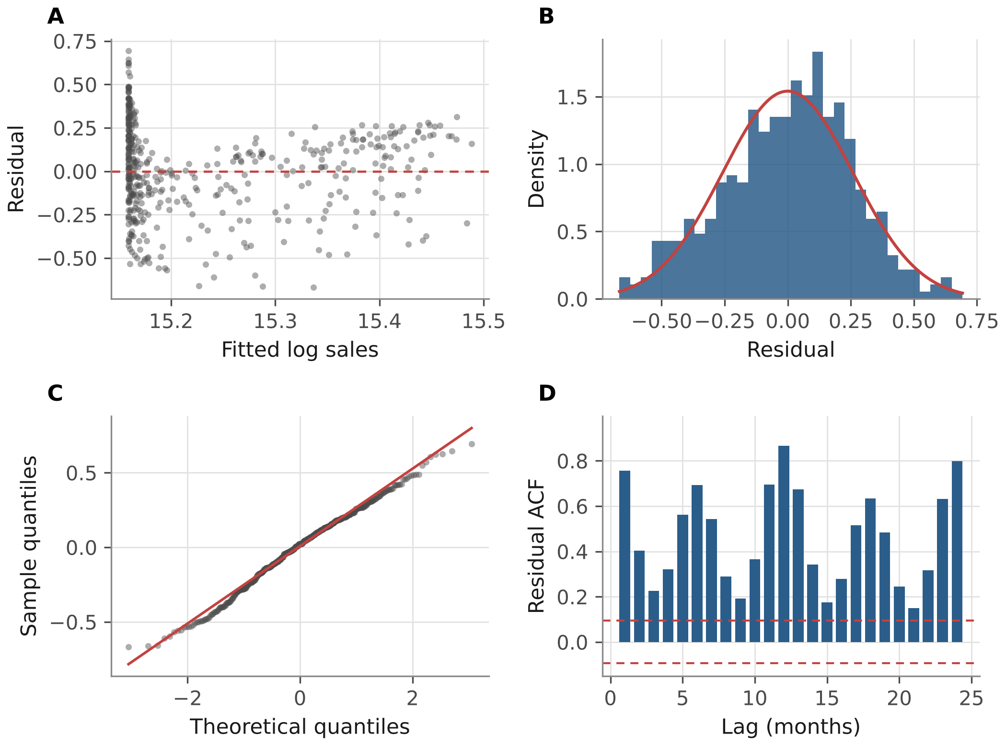
Note. Panel A plots residuals against fitted values, Panel B the residual distribution with a normal curve, Panel C a normal quantile plot, and Panel D the residual autocorrelation function with 95% bounds for white noise. Residual autocorrelation is .76 at lag 1 and .87 at lag 12.
Figure A2
Residual Diagnostics for Model 3
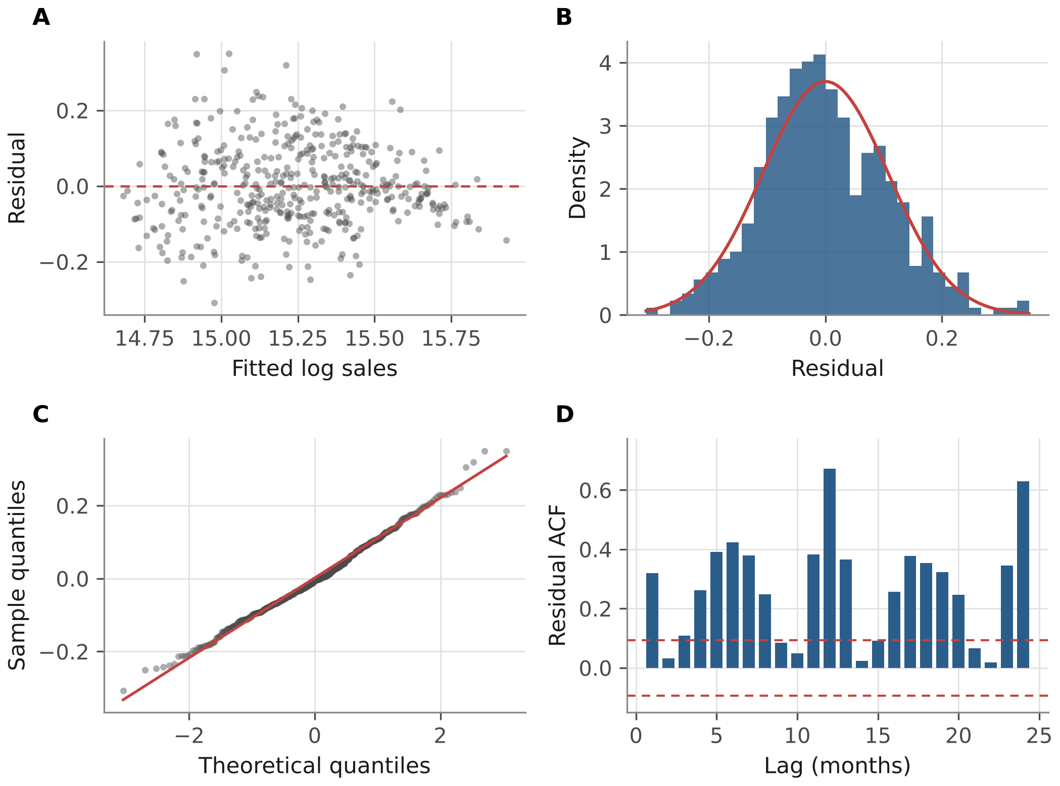
Note. Panel A plots residuals against fitted values, Panel B the residual distribution with a normal curve, Panel C a normal quantile plot, and Panel D the residual autocorrelation function with 95% bounds for white noise. Residual autocorrelation is .32 at lag 1 and .67 at lag 12.
Figure A3
Residual Diagnostics for Model 4
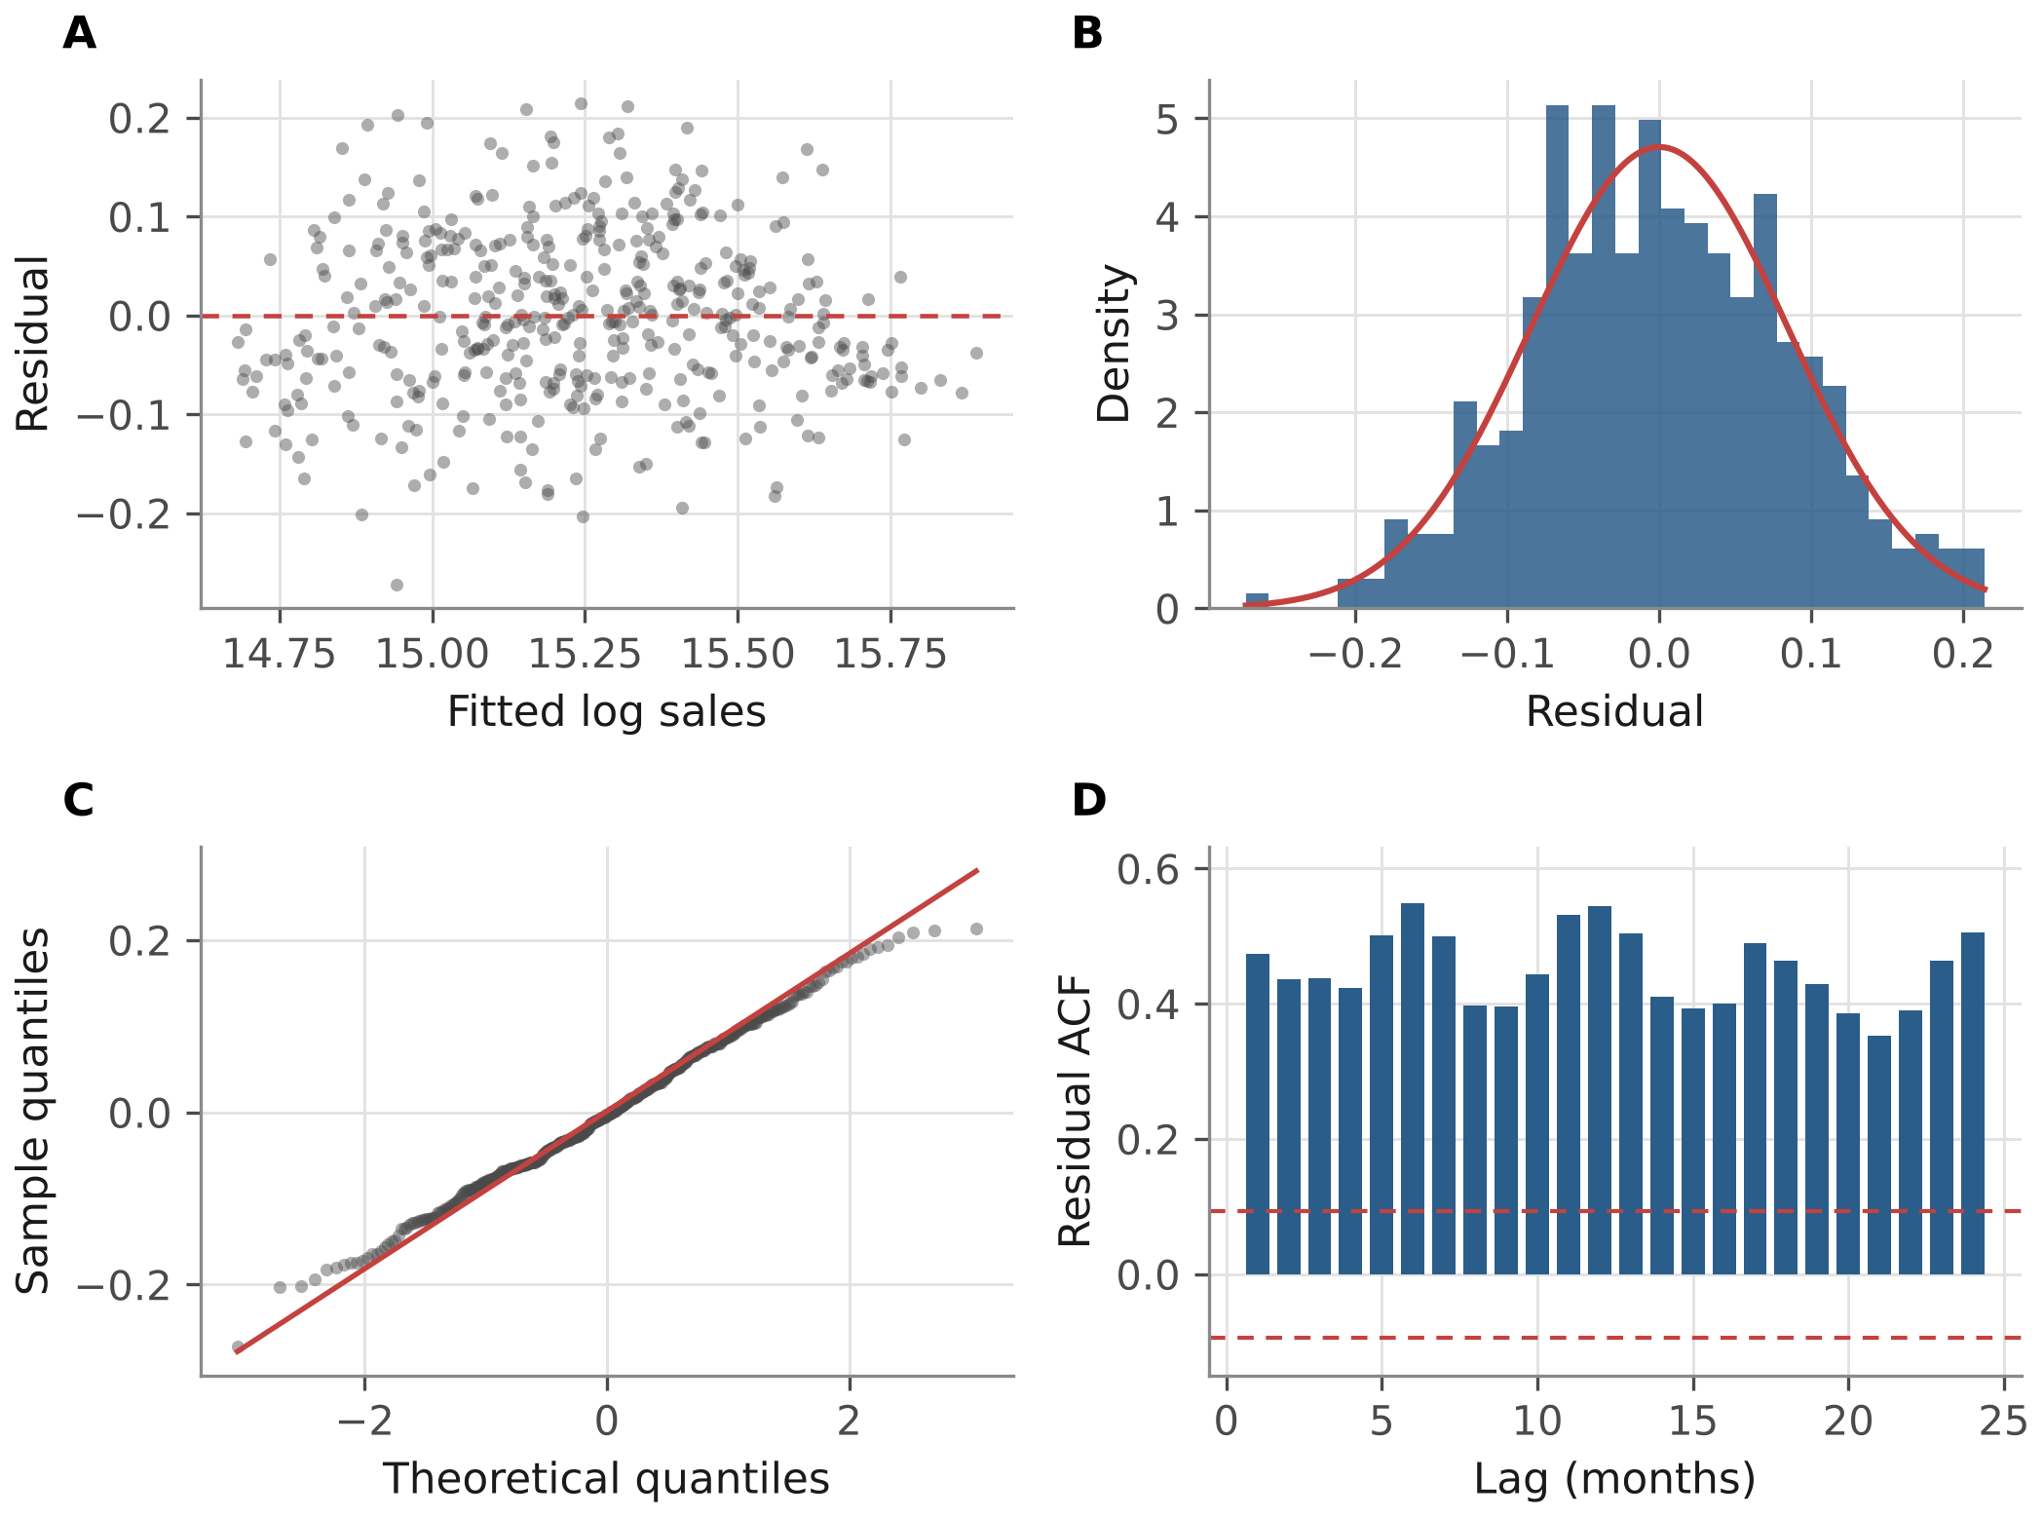
Note. Panel A plots residuals against fitted values, Panel B the residual distribution with a normal curve, Panel C a normal quantile plot, and Panel D the residual autocorrelation function with 95% bounds for white noise. Residual autocorrelation is .48 at lag 1 and .54 at lag 12.

